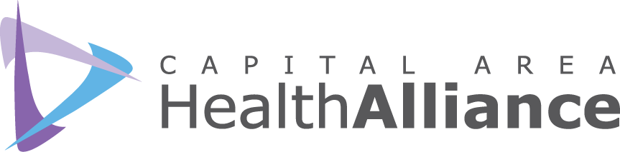

Capital Area Health Alliance - Healthy Lifestyles Committee
October 11, 2017, 9:00-10:30 a.m., Michigan Osteopathic Association

MINUTES
Participants

Kellie Banko, PHP
Kelly Brittain, MSU-CON
Tessa Cox, The Davies Project
Ellen Dreps, HGB/AL!VE
Debbie Edokpolo, ICHD
Irene Gonzalez, Blue Cross Complete
Christine Histed, Tri-County Office on Aging
Kate Hodgkins, ICMCF
Joel Hoepfner, CMHA-CEI
Kathy Hollister, Capital Area Health Alliance
Julie Lehman, Greater Lansing Food Bank
Abbi Lynch, BEDHD
Leslie Polack, Sparrow Health System
Janine Sinno, ICHD
Brianna Sosebee, Capital Area Health Alliance
Casey Thompson, YMCA
Dana Watson, ICHD
Jessica Yorko, ICHD

Call to Order and Introductions. Kathy Hollister chaired the meeting and welcomed attendees. Attendees were given the opportunity to introduce themselves.

Facilitated Discussion/Presentation

- What would Choosing Health!® look like through a health equity lens?
Debbie Edokpolo, Deputy Health Officer and Jessica Yorko, Health Equity & Social Justice Coordinator, both from the Ingham County Health Department, facilitated a discussion on health equity and healthy lifestyles. The HLC discussed the following questions:
  - What does health equity mean to you?
  - What is health disparity?
  - Examples of health inequity were presented: higher diabetes prevalence among blacks and individuals with lower incomes; Native American outreach client story; health & wealth (2-3x higher rates of heart attack, depression and diabetes among low-income); employment rates for black males vs. white males; employers’ replies to “racial names” and impact of neighborhood perception; racial impact of a criminal record on interview callbacks; poverty by race; severe affordable housing problems in Ingham County.
  - 4 Levels of Oppression/Racism: Personal, Interpersonal, Institutional, Cultural
  - What is one thing you can take away from the information presented and today’s discussion in terms of what it means for the health of our community?
  - What are some things our organizations can do to create health equity?
- Individual responses were written and will be shared at next month’s meeting as this discussion continues.

- Partner Updates.
An update was given by Tessa Cox from The Davies Project.

Next Meeting: November 8, 9:00-10:30 a.m., Michigan Osteopathic Association

